Instructions to run the code:

1. Run Spring Boot application and it will run on port no: 8081
2. In-memory database is used and it can be found at : <http://localhost:8081/console>

Console User name : sa Password : password

1. Two users are created with encrypted passwords which can be found on data.sql or on H2 database.
2. All URL’s are secured and need token to access them. Postman URL is used to get access token.

Authorization settings in Postman:

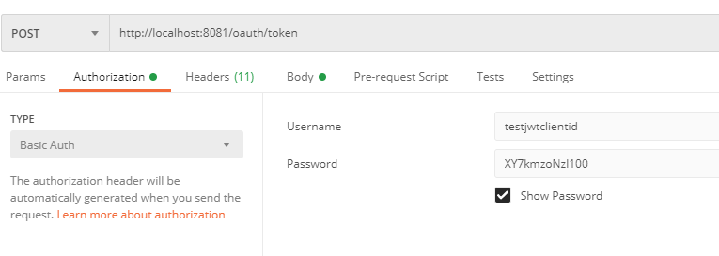

Form parameters to get token:

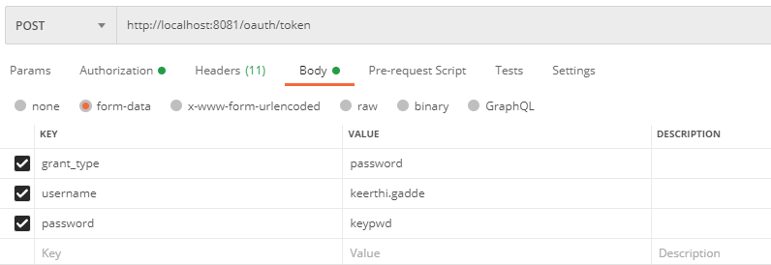

1. Copy the access token from the response.
2. Creation of account

URL : <http://localhost:8081/accounts>

Method: POST

Header: Authorization bearer copied token

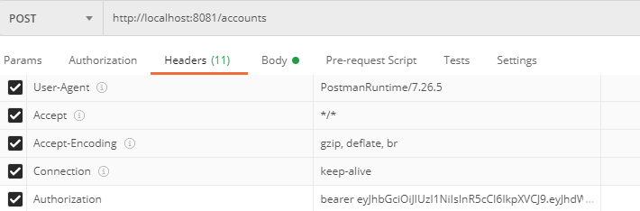

Body:

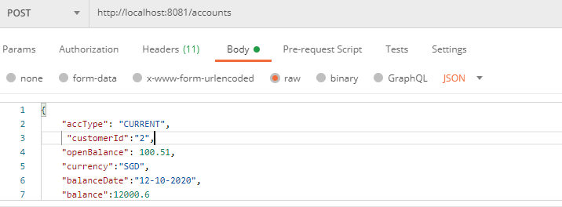

{

    "accType": "CURRENT",

     "customerId":"2",

    "openBalance": 100.51,

    "currency":"SGD",

    "balanceDate":"12-10-2020",

    "balance":12000.6

}

1. GET REQUEST for Accounts: <http://localhost:8081/accounts>

Without passing page parameters

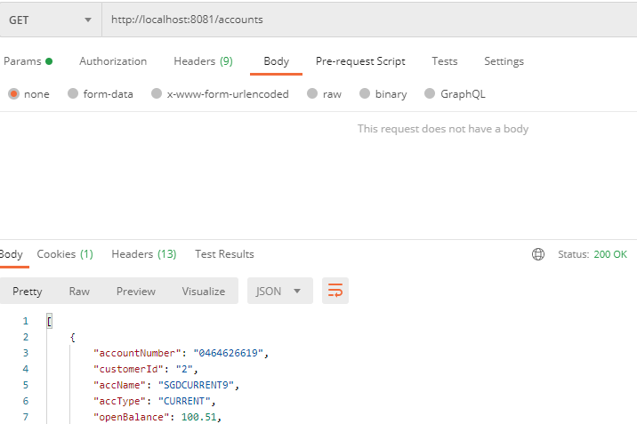

8.GET REQUEST for Accounts: <http://localhost:8081/accounts>

You can pass pagination parameters also

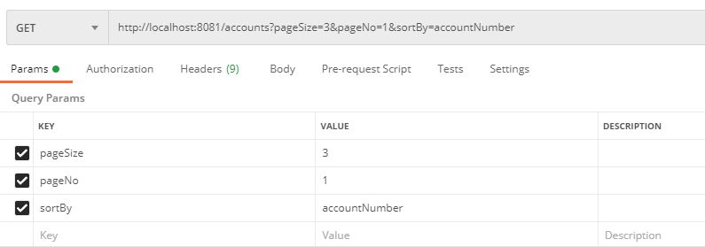

9 .Creation of transaction.

URL: <http://localhost:8081/transactions>

Method: POST

Header: Authorization bearer copied token

Body

{

    "accountNumber": "5963313131",

    "transType": "Debit",

    "amount": 2000.51,

    "currency":"SGD",

    "description":"test"

}

Follow the instructions mentioned in the Accounts sections above for reference.

10. Getting Transactions for account number

Method : GET  
